Umezakia ovalisporum (Forti) McGregor et al. 2023
Previous name used: Aphanizomenon ovalisporum Forti 1911
Phylum: Cyanobacteriophyta
Class: Cyanophyceae
Order: Nostocales

Habitat: plankton
Distinctive attributes: gas-vacuolated filamentous cyanobacterium, often with heterocytes and/or akinetes. End-cells are bluntly rounded, thinner than other cells, often colorless. Filament diameter larger than that of Raphidiopsis (previously Cylindrospermopsis) raciborskii.
Organization: filamentous
Color: pale blue-green
Cell diameter (D): 3.0–4.4 µm, median: 3.4 µm (N=3980). Cell diameter varies significantly over an annual cycle, making it necessary to measure it routinely
Cell length (L): not measured, only filament length was measured
Filament length: 20–1100 µm, median: 190 µm (N=3980)
Cell biovolume: not computed, only filament volume was computed
Biovolume equation: Cylinder, V = 2 π L (D/2)², where L=filament length
Morphological features:
Solitary planktonic trichomes, straight or slightly curved, several hundred µm long, 3-4 µm wide, with bluntly rounded or slightly tapered end cells; scarcely constricted at the cross walls (Plates 1, 2). Vegetative cells are cylindrical, 1-3 times longer than wide, at the ends of the trichome, up to 6-7 times longer than wide, gradually becoming longer and often reaching 25-30 µm in length; with gas vesicles. Color: pale blue-green, but end cells often colorless. Heterocytes solitary, intercalary (between two other cells; never at end of trichome), nearly spherical or ellipsoidal, 2-6 µm wide (median: 3.4 µm) and 2.5-9 µm long (median: 5.30. Akinetes (resting cells) oval, usually separated by vegetative cells from heterocytes on the same trichome, up to 3-14 µm (median: 6.7 µm) wide and 5-23 µm long (median: 10.2 µm), with a yellow or brown envelope. Reproduction by fragmentation of trichomes and by germination of akinetes. The species can be distinguished from the other common nostocalean cyanobacterium, Raphidiopsis (previously Cylindrospermopsis) raciborskii by its end cells. In U. ovalisporum they are thinner than the rest of the trichome cells and partly or completely hyaline with a blunt ending (Plate 2), as opposed to the pencil-/needle-shaped ending or a terminal heterocyte in U. raciborskii. Cell diameter is also larger in U. ovalisporum (Plate 3).
Plate 1. Three filaments of Umezakia ovalisporum from Lake Kinneret. Top filament – with an akinete (large egg-shaped central cell). Middle and top filaments – with a heterocyte (“empty rounded central cells). Photo by Alla Alster.
Plate 2. Filaments of Umezakia ovalisporum in a culture isolated from Lake Kinneret. When no heterocytes and/or akinete are seen, the species can be identified by its end cells, that are typically longer and thinner than other cells in the filament, and with hyaline (colorless) parts. Yellow scale bar = 10 µm. Photo by Alla Alster, June 2006.
Plate 3. Two filaments of Umezakia ovalisporum on either side of a single (central) filament of Raphidiopsis (previously Cylindrospermopsis) raciborskii. The distinction between species is by examination of the end cells. In U. ovalisporum they are thinner than the rest of the trichome cells and partly or completely hyaline with a blunt ending, as opposed to the pencil-/ needle-shaped ending or a terminal heterocyte in U. raciborskii. Cell diameter is also larger in U. ovalisporum. Photo by Alla Alster, June 2006.

Ecology: Umezakia ovalisporum, a nitrogen-fixing cyanobacterium invaded Lake Kinneret in 1994 (Pollingher et al. 1998), shortly after the Hula Valley was hydrologically disconnected from Lake Kinneret when Lake Agmon was created (Hambright and Zohary 1998). This disconnection reduced substantially the nitrate load entering Lake Kinneret and created in-lake conditions suitable for the proliferation of nitrogen fixers. Umezakia ovalisporum was the first of several species of nostocalean cyanobacteria never recorded previously that appeared in Lake Kinneret since 1994 and got established in the lake. In September-October 1994 U. ovalisporum formed a massive bloom in Kinneret (Fig. 1). Since 1994 it is a common component of the Kinneret summer phytoplankton. It occurs in the plankton only when the lake is stratified, peaking in September-October (Fig. 2). Towards the onset of winter, it forms akinetes (Plate 1) that sink to the sediment and wait for germination till the following summer. This species is usually evenly distributed throughout the epilimnion. In Kinneret it doesn’t form surface films and doesn’t cluster.
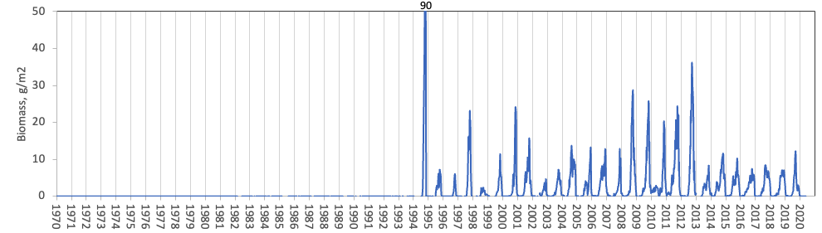
Figure 1. Time series of Umezakia (Previously Aphanizomenon) ovalisporum depth-integrated wet-weight biomass (g m⁻²), Lake Kinneret, 1970-2020.
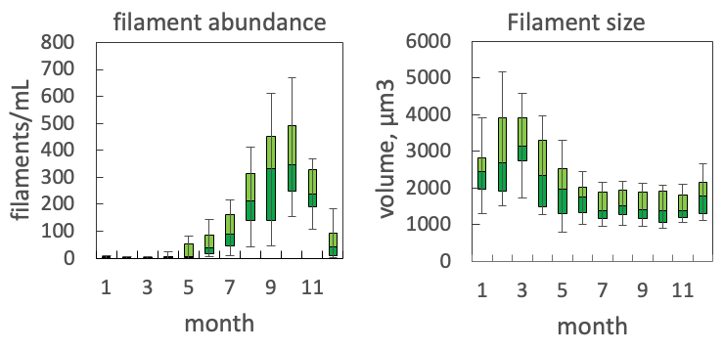
Figure 2. Box plots showing the seasonal pattern of statistics of water column filament abundance (left) and volume per filament (right) of Umezakia ovalisporum, based on data for 2004-2020.
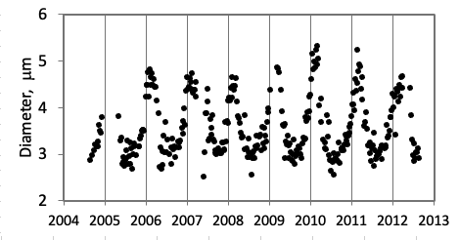
Figure 3. Seasonal fluctuations in filament diameter of Umezakia ovalisporum, 2004-2012 (all measurements made by the same analyst), showing larger diameter in winter, smaller in summer. Vertical lines mark 1 January of each year.

Physiological features:
Like other nostocalean species, it fixes atmospheric nitrogen. N-fixation happens in the heterocytes, where anoxic conditions are maintained. It produces the toxin cylindrospermopsin and hence considered bad for water quality. Potassium deficiency triggers the development of akinetes (Sukenik et al. 2013).

Environmental conditions:
Umezakia ovalisporum disappears when the pH exceeds 9 (Fig. 3) although its intense blooms push the pH towards this level. It is adapted to higher salinities, higher water temperatures, lower TP levels. In lab experiments, A. ovalisporum hardly grew under Na+ lower than 2.5 mM (Bar Yosef thesis, P.9, based on Kaplan et al. 1984. FEBS letters 176:166-168).

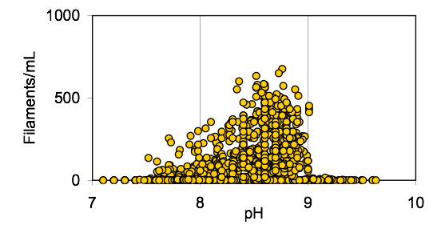
Figure 3. pH tolerance of U. ovalisporum, based on Kinneret field data.

Figure 4. U. ovalisporum abundance (cells mL⁻¹) vs. environmental parameters recorded at the site and time of sampling, showing...

Further reading:
Bar‐Yosef Y, Murik O, Sukenik A, Hadas O, Kaplan A. 2012. Multiannual variations in phytoplankton populations: what distinguished the blooms of Aphanizomenon ovalisporum in Lake Kinneret in 2010 from 2009? Environmental Microbiology Reports, 4:498-503.
Bar-Yosef Y, Sukenik A, Hadas O, Viner-Mozzini Y, Kaplan A. 2010. Enslavement in the water body by toxic Aphanizomenon ovalisporum, inducing alkaline phosphatase in phytoplanktons. Current biology, 20:1557-61.
Hadas O. 2014. Microbial processes within the nitrogen cycle. Chap. 22 In: Zohary T, Sukenik A, Berman T, Nishri A. [eds] Lake Kinneret: Ecology and Management, pp 381-396. Springer, Heidelberg.
Hadas O, Pinkas R, Malinsky‐Rushansky N, Nishri A, Kaplan A, Rimmer A, Sukenik A. 2012. Appearance and establishment of diazotrophic cyanobacteria in Lake Kinneret, Israel. Freshwater Biology, 57:1214-27.
Hadas O, Pinkas R, Malinsky-Rushansky N, Shalev-Alon G, Delphine E, Berner T, Sukenik A, Kaplan A. 2002. Physiological variables determined under laboratory conditions may explain the bloom of Aphanizomenon ovalisporum in Lake Kinneret. European Journal of Phycology, 37:259-267.
Hadas O, Kaplan A, Sukenik A. 2015. Long-term changes in cyanobacteria populations in Lake Kinneret (Sea of Galilee), Israel: an eco-physiological outlook. Life. 5:418-31.
Hambright KD, Zohary T. 1998. Lakes Hula and Agmon: destruction and creation of wetland ecosystems in northern Israel. Wetlands Ecol. Manag. 6: 83-89.
Hambright KD, Zohary T, Easton J, Azoulay B, Fishbein T. 2001. Effects of zooplankton grazing and nutrients on the bloom-forming, N₂-fixing cyanobacterium Aphanizomenon in Lake Kinneret. J. Plankton Res. 23:165–174.
(Kaplan et al. 1984) FEBS letters 176(1) 166-168.
McGregor GB, Sendall BC, Niiyama Y, Tuji A, Willis A. 2023. Chrysosporum ovalisporum is synonymous with the true-branching cyanobacterium Umezakia natans (Nostocales/Aphanizomenaceae). Journal of Phycology 59: 326-341.
Pollingher U, Hadas O, Yacobi YZ, Zohary T, Berman T. 1998. Aphanizomenon ovalisporum (Forti) in Lake Kinneret (Israel). J. Plankton Res. 20: 1321-1339.
Sukenik A. Hadas O, Kaplan A. 2014. Cyanobacteria. Chapter 12 In: Zohary T, Sukenik A, Berman T, Nishri A. [eds] Lake Kinneret: Ecology and Management, pp. 213-226. Springer, Heidelberg.
Sukenik A, Kaplan‐Levy RN, Viner‐Mozzini Y, Quesada A, Hadas O. 2013. Potassium deficiency triggers the development of dormant cells (akinetes) in Aphanizomenon ovalisporum (Nostocales, Cyanoprokaryota). Journal of phycology, 49:580-7.
Zohary T, Yacobi YZ, Alster A, Fishbein T, Lippman S, Tibor G. 2014. Phytoplankton. Chap. 10 In: Zohary T, Sukenik A, Berman T, Nishri A. [eds] Lake Kinneret: Ecology and Management, pp. 161-190. Springer, Heidelberg.

